Algebra 1: Unit 12, Lesson 2

- Data can be classified as categorical or numerical and univariate (one variable) or bivariate (two variables).
Your favorite method of exercise (walking, running, lifting weights, or swimming).
How can this data be classified?
Categorical, univariate data

- Apple's revenue from iPod sales, in millions of dollars, from 2002 to 2014 is shown in the table.
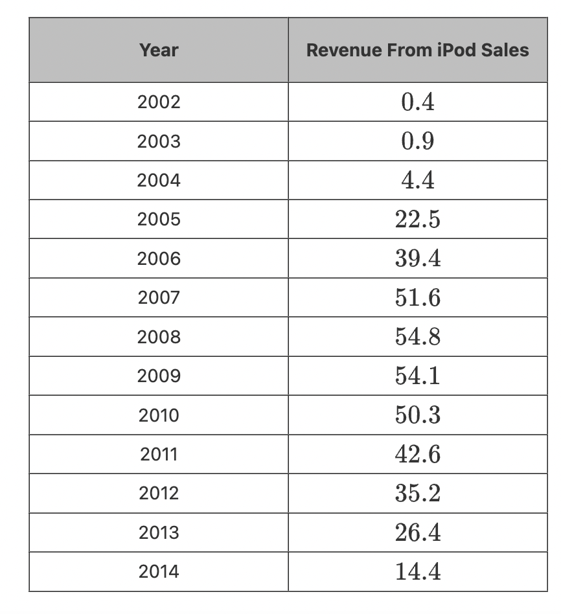
Classify the data in the table as categorical or numerical and univariate (one variable) or bivariate (two variables).
Numerical, bivariate data

- The price per gallon of gas, in dollars, in January of each year from 1994 to 2014 is shown in the table.

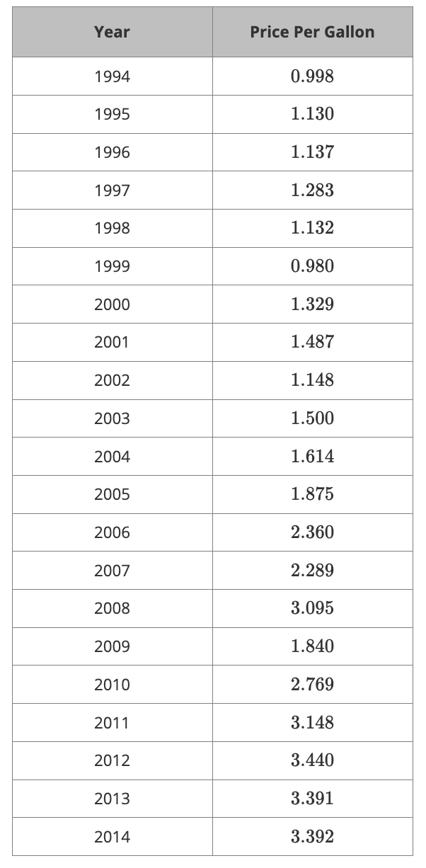
A large amount of data is displayed in the table. What type of graph would be helpful to display the data, a line plot or a scatterplot?
scatterplot

